**Instructions:**

Hover over the name in the signature, then right click on the cross icon like the example below.

Select copy, and then paste into the edit signature box in you outlook options.

[Video tutorial](https://www.youtube.com/watch?v=cnUKONq_WoI)

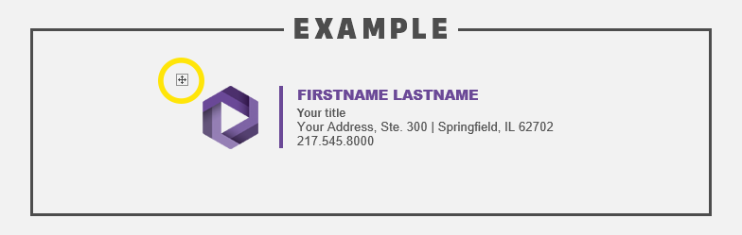

**Signature to copy:**

|  |  |
| --- | --- |
| cid:image007.png@01D25AAC.1E9917B0 | FIRSTNAME LASTNAME  Your title  Your Address, Ste. 000 | Springfield, IL 62702  217.545.8000 |